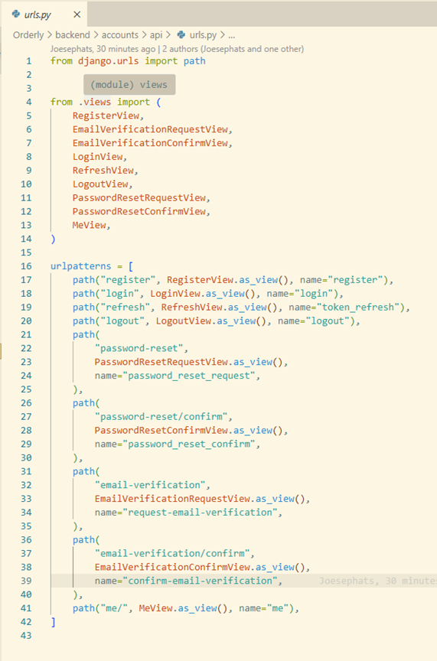
Login code Kim and Tristan
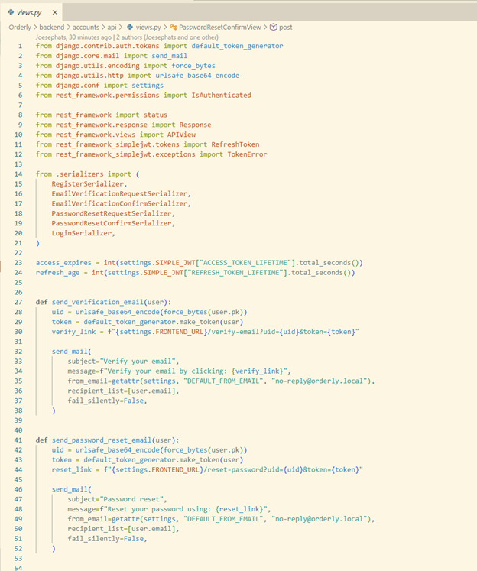
Login code Kim and Tristan

Login code Kim and Tristan

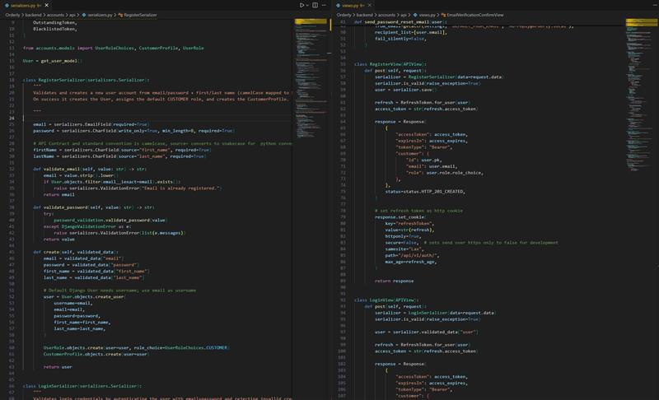
Login code Tristan

